**Tableau 2019.4 New Features**

1. Webhooks Support
2. Sandbox Extensions
3. Explain Data Improvements
4. User visibility site control
5. Level AA Accessibility compatibility
6. Ask Data Improvements
7. SAP HANA Connector Improvements
8. LinkedIn Sales Navigator connector
9. Data Quality Warnings for tableau mobile
10. Activity feed Improvements
11. Table improvements
12. Auto recover Web authoring sessions
13. Creating Extracts in the Web browser
14. Custom welcome banner for tableau server
15. Edit tooltips in the browser
16. Map improvements in the browser
17. View Recommendations
18. Go to where a sheet is used
19. Qubole Connector
20. Kyvos Connector
21. Alibaba Connectors
22. Cloud file connectors for Table
23. App lock using biometrics
24. **Webhooks Support**:

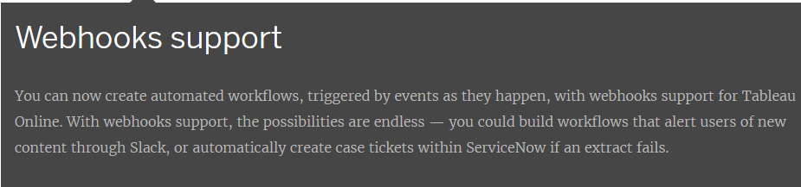

We can create Automated Workflows, triggered by events as they happen, with webhooks support for tableau online. 🡪 It could build workflows that alert users of new content through slack, or automatically create case tickets within service now if an extract fails.

1. **Sandbox Extensions:**

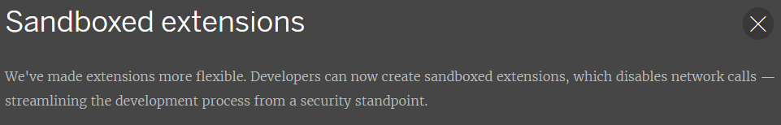

Extensions are more flexible, developers can now create sandboxed extensions, which disables network calls—streamlining the development process from a security stand point.

1. **Explain Data Improvements:**

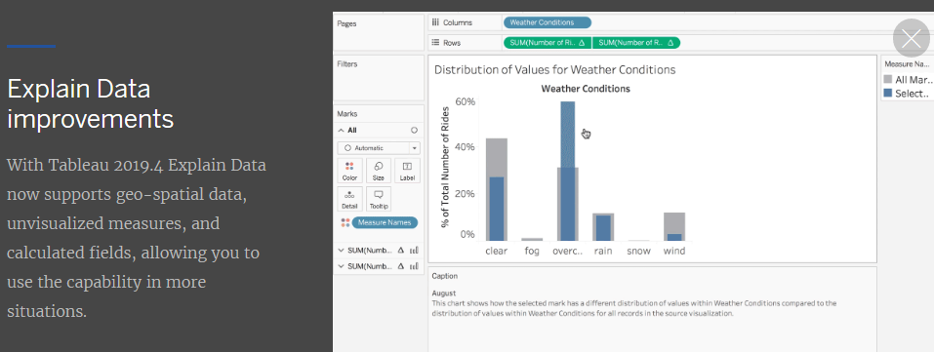

Earlier we have option explain data – but in that it’s not showing Reference lines in marks level view ,now 2019.4 we have option whatever we are selected the mark to describe that mark and showing reference lines on that.

Explanations show the relationship between the target measure and the unvisualized measure for all marks in the source visualization.

1. **User visibility site control:**

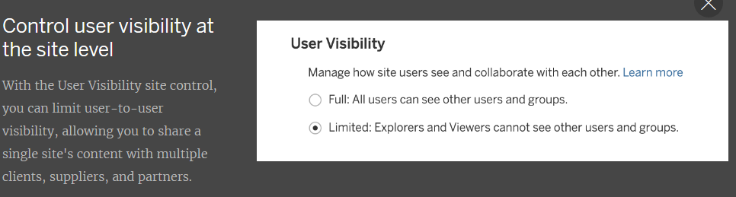

We have option to User Visibility Site control you can limit user-to-user visibility, allowing you to share a single site’s content with multiple clients, suppliers and partners.

1. **Level AA accessibility compatibility:**

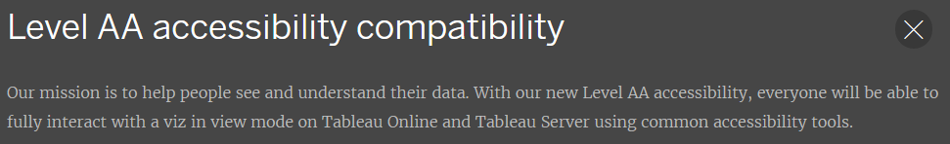

By using common accessibility tools everyone can able to fully interact with a viz in view mode on tableau server and tableau online.

1. **Ask Data improvements:**

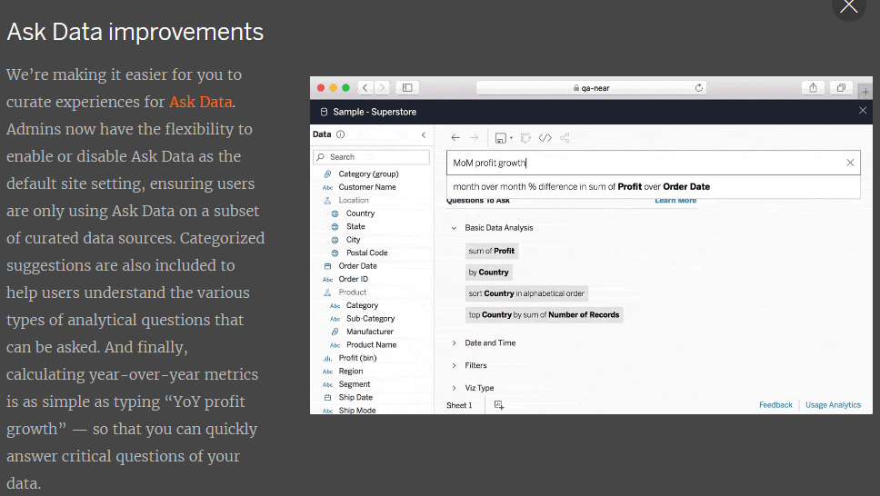

Here in 2019.4 added features of Ask Data Improvements on subset of data sources. Categorized suggestions are also included to help users understand the various types of analytical questions that can be asked and finally calculating the YOY metrics is as simple as typing ‘YOY Profit Growth’—so that we can quickly answer critical questions of your data.

1. **SAP HANA connector improvements:**

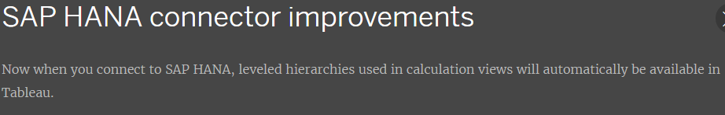

We can connect to SAP HANA leveled hierarchies used in calculation views will automatically be available in Tableau.

1. **LinkedIn Sales Navigator connector:**

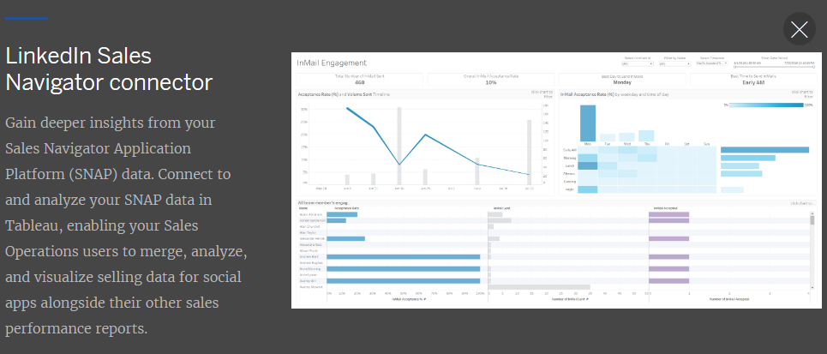

SNAP - Sales Navigator Application Platform. To connect and analyze you SNAP data in tableau, enabling your sales operations users to merge, analyze and visualize selling data for social apps alongside their other sales performance reports. (CRM, Business Intelligence, Marketing Automation, Sales Acceleration, Web Conferencing, eSignature Others Sales Applications with linkedIn sales navigator with in a single selling experience.)

1. **Data quality warnings for Tableau Mobile:**

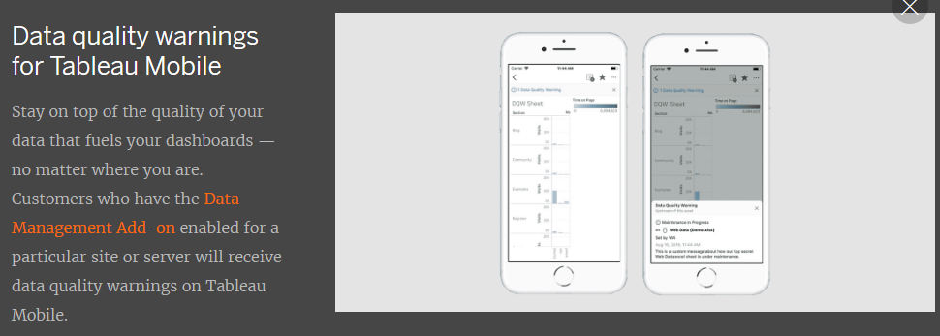

Customers who have the Data Management Add-on enabled for a particular site or server will receive data quality warnings on tableau mobile.

1. **Activity feed improvements:**

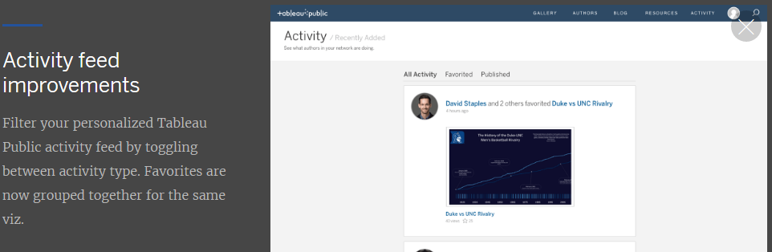

Filter your personalized tableau public activity feed by toggling between activity types. Favorites are now grouped together for the same viz.

1. **Table Improvements:**

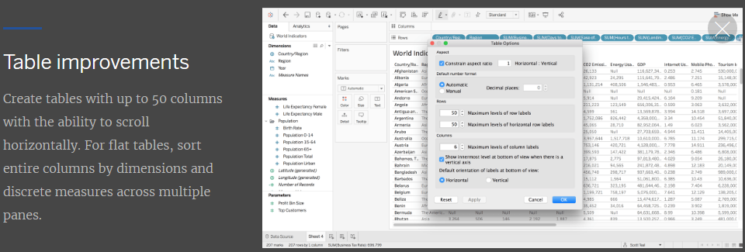

Earlier we have only 16 entire columns by dimensions and discrete measures , now we have option create tables with up to 50 columns with the ability to scroll horizontally.

1. **Auto recover web authoring sessions:**

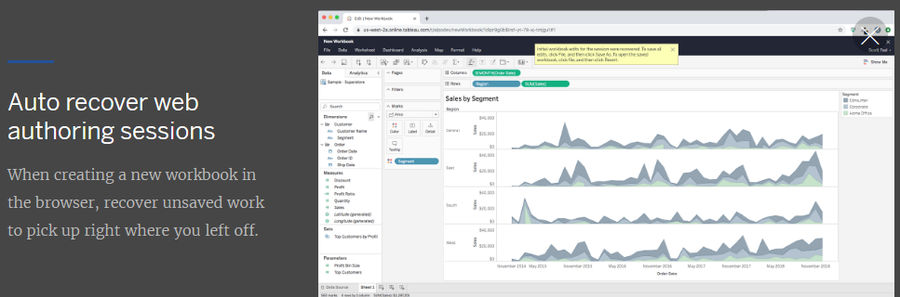

When creating a new workbook in the browser, recover unsaved work to pick up right where you left off.

1. **Create extracts in the browser:**

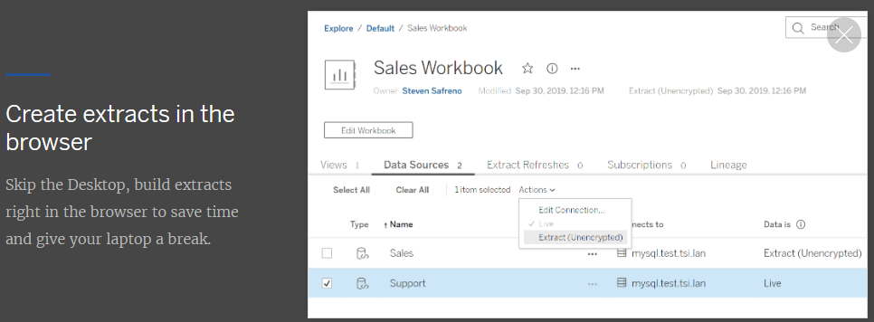

Here we have option skip the desktop build extracts right in the browser to save time and give your laptop a break.

1. **Custom welcome banner for Tableau Server:**

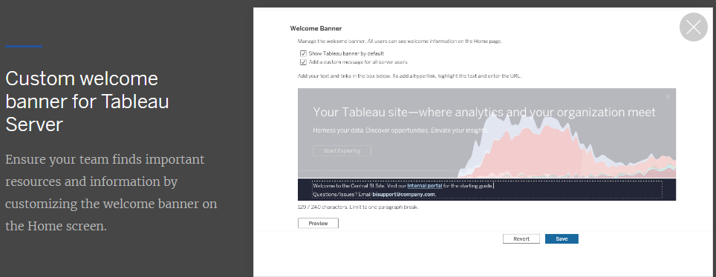

Here an option that customizing the welcome banner on the home screen.

1. **Edit tooltips in the browser:**

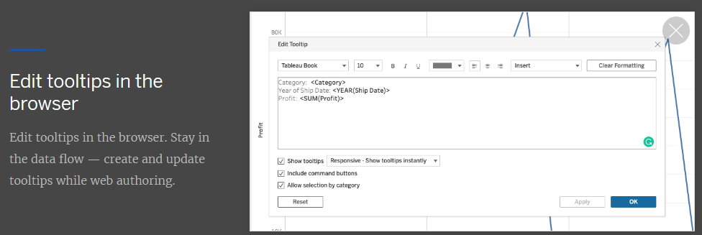

Here we have an option that we can edit tooltips in the browser level only. Create and update tooltips while web authoring.

1. **Map improvements in the browser:**

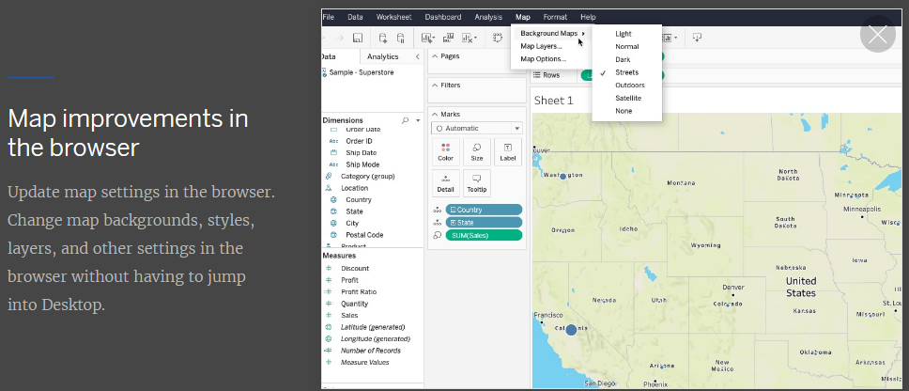

Now we have an option that updates map settings in the browser. Change map backgrounds, styles, layers and other settings in the browser without having to jump into desktop.

1. **View Recommendation:**

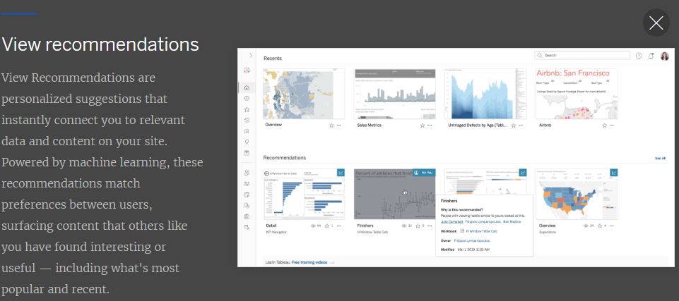

1. **Go to where a sheet is used:**

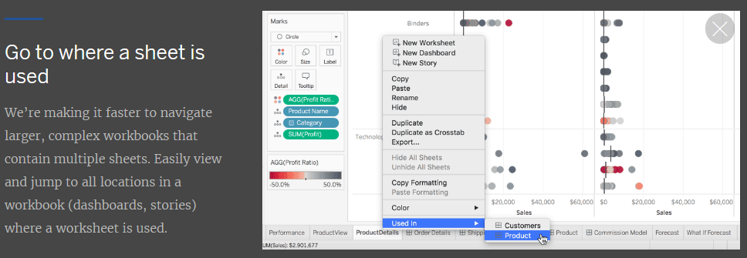

Here we have new option that “Used In” It will showing all dashboards where ever that sheet showing. Easily view and jump to all locations in a workbook (dashboards, stories) where a worksheet is used.

1. **Qubole Connectors:**

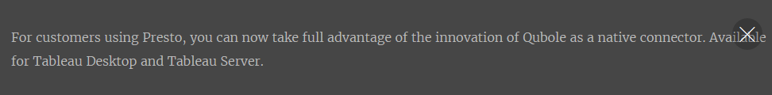

The customers using presto, you can now take full advantage of the innovation of Qubole as a native connector. Available for Tableau Desktop and Tableau Server.

1. **Kyvos Connectors:**

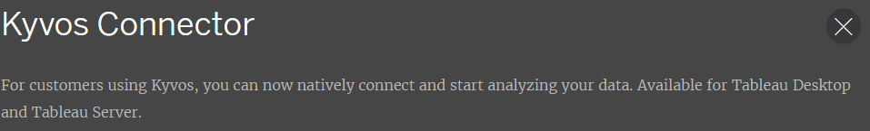

Customers using Kyvos, you can now natively connect and start analyzing your data. Available for Tableau Desktop and Tableau Server.

1. **Alibaba Connectors:**

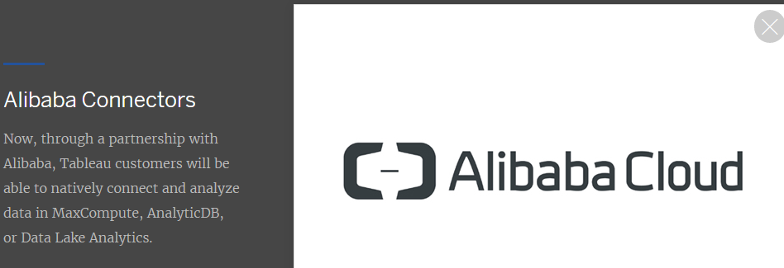

Through a partnership with Alibaba, Tableau customers will be able to natively connect and analyze data in MaxCompute, AnalyticDB, or Data Lake Analytics.

1. **Cloud file connectors for tableau Prep:**

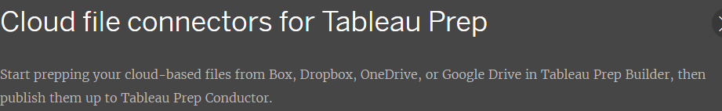

Start preparing your cloud-based files from box, drop box, OneDrive, or Google Drive in Tableau Prep Builder, and then publish them up to Tableau Prep Conductor**.**

1. **App lock using biometrics:**

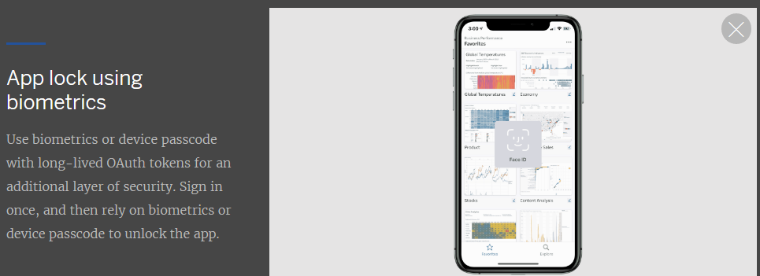

Bio-Metrics or device passcodes with long-lived OAuth tokens for an additional layer of security. Sign in once, and then rely on biometrics or device passcode to unlock the app.